**PROJECT REPORT**

**TITLE:**

**Real Time Weather Based Smart Sprinkler System For Golf Course**

**SUBMITTED BY : Ayan Akhtar**

**INTRODUCTION**

**OVERVIEW:** One of the major factors in the design, refurbishment, and long-term maintenance of any golf course is the way the greens and fairways are watered. In some golf courses watering systems such as sprinklers or drip water wires are fitted to sprinkle the water automatically and reduce human load. Normally sprinkler systems operate with respect to time, which means if we program it at 9 am it will be on even if rain occurs during that particular time. Since water is a precious resource we need to use it very carefully. The Internet of things will make the system more efficient.

The project focuses on Continuous monitoring and storage of weather and soil moisture information of the golf course and generating an alert if the soil moisture is above the threshold value .The water sprinklers will be controlled remotely using mobile app .Less latency in communication from device to cloud with MQTT.

**PURPOSE:** One of technologies in the rise, the Internet Of Things has started to provide a new way for analysis, luxury, efficiency and hassle free working in several sectors of the industry and other places. You can sense accurate temperature parameters inside a cold storage or at a furnace and send alert messages to the responsible authorities hence averting danger. You can control your house electricity when your are away and also figure out intruders if any, inside .There are several examples and utilities of IOT. As a part of every technology race, it has also become a part in every core company's work flow wherein they always try their hand at this.

**LITERATURE REVIEW**

Water conservation is one of the key and tactical challenges that the humanity possess . Controlling the ways its wasted is quite important and with the help of IOT devices, one knows the right amount of water requirements for all types of irrigation systems, Dam checks etc; There are several other challenges that IOT can help us to overcome such as it can help us in social distancing by triggering an alarm using a PIR sensor. It can help in monitoring waste water treatment by several industries and alert the authorities the minute any of the levels go inappropriate. Overall , IOT is a booming market and a plethora of ideas put together from both hardware and software domains working in unison.

**PROPOSED SOLUTION:** In the proposed solution the temperature, humidity, and soil moisture levels in the golf course should be continuously monitored, updated to AWS IoT Core, and store the data in dynamo DB.by considering the weather forecasting details from the open weather API the system should control the sprinklers automatically. Develop a mobile app to visualize the soil moisture and weather parameters.

Project Flow:

* Configure and connect the online simulator to publish temperature, humidity, and soil moisture values to AWS IoT core.
* Create the rules and actions to store data in Dynamo DB
* Create an API to retrieve the data from Dynamo DB using API Gateway and Amazon Lambda functions.
* Create a mobile app to visualize the sensor parameters and also to get the open weather data.
* Configure the mobile app to send commands to AWS IoT core to control the sprinklers based on the sensor values and weather details.

**THEORITICAL ANALYSIS**

**BLOCK DIAGRAM:**

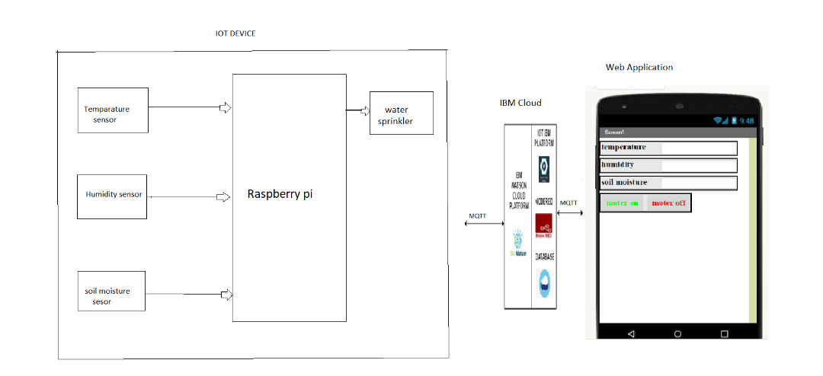

**SOFTWARE DESIGNING:** In the software designing part create a IBM cloud platform. In this design the raspberry pi model is used. the software should be design by taking avalues from the dht11 sensor and then sent to the IBM cloud services and then the data send to the mobile application which was developed using MIT app inventor. Here we use python language for coding, Node-Red ,etc.



**Experimental Investigation:**

There are DHT11 sensors placed at the Golf course every water sprinkler and sensors are connected with the IOT device. The temperature sensor and soil moisture sensor take the values regularly and it was sent to IOT device. This IOT device will send the information to our mobile phone. By observing the weather conditions, we pass the instructions weather water sprinkler is ON/OFF.

**Flow Chart:**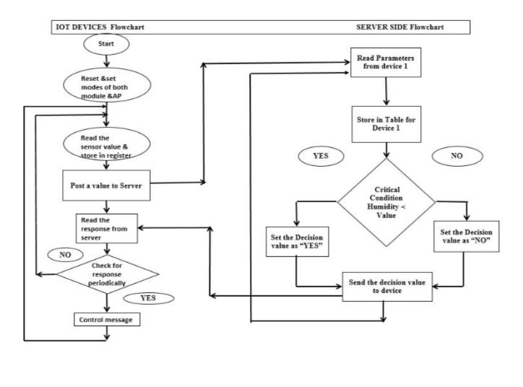

**RESULT:**

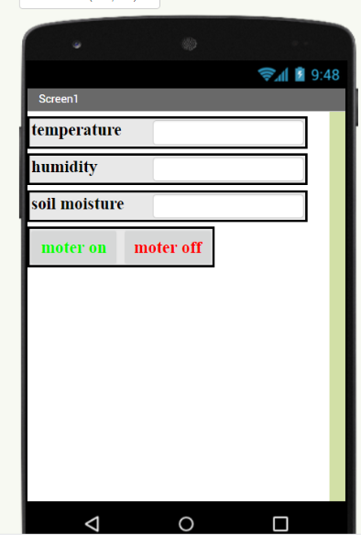

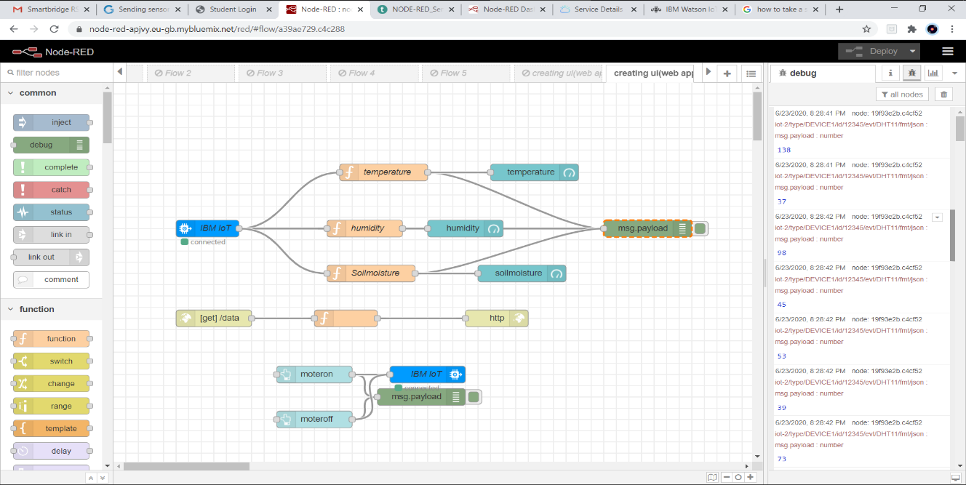

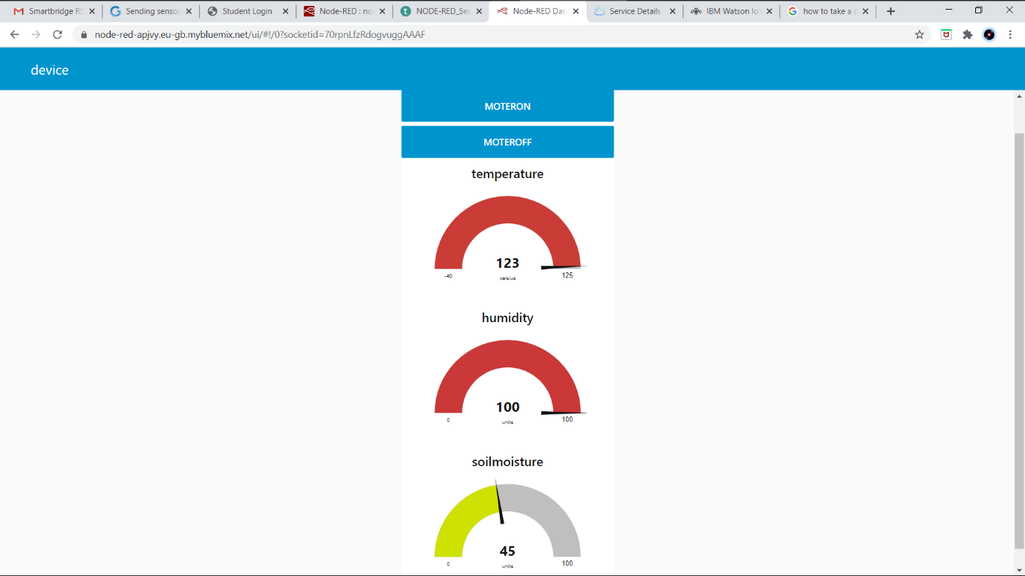

**ADVANTAGES & DISADVANTAGES:**

**Advantages:**

* Without Human effort we maintain the good Golf course.
* Supervision by online: We get regular weather report. Because the temperature and moisture sensor will give regular notifications.
* Save a ton of money by reducing water waste.
* Enhanced landscape health and beauty.
* Helps us to prepare for the future of water.

**Disadvantages:**

* The weather based smart water sprinkler system is a bit expansive depending on the size of your ground, we will need more systems.
* The Golf course has the very large area. To spread over all the ground, we require the more systems and observation become difficult.

**APPLICATIONS:**

It is used in all the Golf courses, supervision by online using IOT device. We avoid the water wastage and get the good ground. We use this project in all type of play grounds.

**CONCLUSION:**

* The project Real time weather based smart sprinkler system for Golf course is very useful.
* By this we can decrease the WATER WASTAGE.
* We observe the weather conditions in the Golf course by online.
* We switch ON/OFF of water sprinkler by online using IOT device.
* This will decrease the human efforts.
* This project will also use the many Play grounds.

**FUTURE SCOPE:**

Now a days, many of the Golf course and Play grounds using these types of systems. In Future everywhere in every field people use the Internet of Things projects. Because the projects will reduce the human efforts and wastage of nature.

**BIBLIOGRAPHY:**

* [**www.google.com**](http://www.google.com)
* [**www.wikipedia.com**](http://www.wikipedia.com)

**APPENDIX:**

import time

import sys

import ibmiotf.application

import ibmiotf.device

import random

#Provide your IBM Watson Device Credentials

organization = "6iwuiq"

deviceType = "DEVICE1"

deviceId = "12345"

authMethod = "token"

authToken = "12345678"

# Initialize GPIO

def myCommandCallback(cmd):

print("Command received: %s" % cmd.data)

print(type(cmd.data))

i=cmd.data['command']

if i=='moteron':

print("moter is on")

else:

print("moter is off")

try:

deviceOptions = {"org": organization, "type": deviceType, "id": deviceId, "auth-method": authMethod, "auth-token": authToken}

deviceCli = ibmiotf.device.Client(deviceOptions)

except Exception as e:

print("Caught exception connecting device: %s" % str(e))

sys.exit()

deviceCli.connect()

while True:

hum=random.randint(30,100)

temp = random.randint(30,150)

moisture= random.randint(0,100)

#Send Temperature & Humidity to IBM Watson

data = { 'Temperature' : temp, 'Humidity': hum, 'Soilmoisture' : moisture}

#print (data)

def myOnPublishCallback():

print ("Published Temperature = %s C" %temp, "Humidity = %s %%" %hum,"Soiloisture= %s" %moisture,"to IBM Watson")

success = deviceCli.publishEvent("DHT11", "json", data, qos=0, on_publish=myOnPublishCallback)

if not success:

print("Not connected to IoTP")

time.sleep(2)

deviceCli.commandCallback = myCommandCallback

# Disconnect the device and application from the cloud

deviceCli.disconnect()